2025
Sonali ETC System………….

Sonali Bank PLC

[Integration with ETC System]
Powered by Sonali Bank PLC

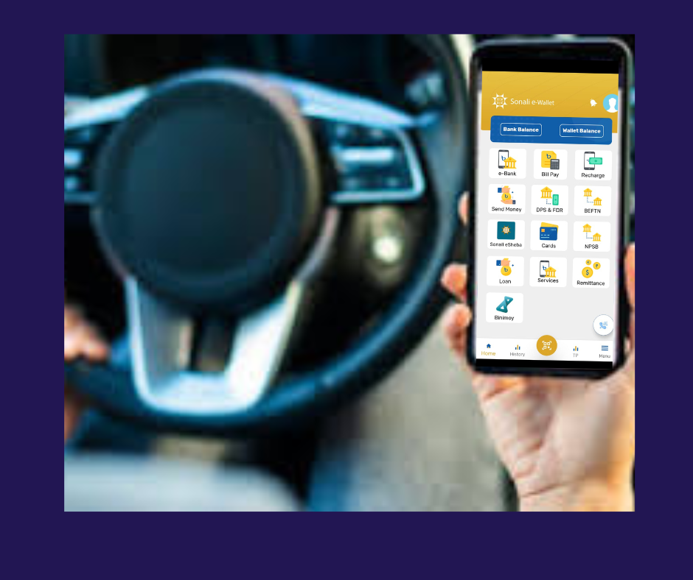
Summary:
This Integration document contains the information for collection of Toll with integration Bank. in this case we can define - direct integration with bank account (sonali e-wallet)
Sonali e-Wallet: - Sonali e-wallet is smart banking system, customer can registration through e-wallet and when a toll system send a payment request then sonali e-wallet confirm payment directly customer account.
- Commitment of Services:
- Self Payment Service of Customers
- 24x7 services
- Online & sonali e-wallet
- API based Integrations
- Automatic Reconciliation
- Regular Settlement & confirm a-challan / bank account next day
- Real time monitoring panel

- Transaction Flow:
- Integration with Sonali e-Wallet:
customer
2
1
SBL Toll Pay System
Sonali e-Wallet
5
3

4
vehicle
ETC Toll System

- Steps of Flow Diagram: Sonali e-Wallet Integration with ETC Toll Collection System

Registration:
Sonali e-Wallet customers can register to ensure sufficient balance for making toll payments via their Sonali e-Wallet account.

Registration Request Submission:
The Sonali e-Wallet system sends the registration request to the ETC Toll Collection System through the Sonali Bank Toll Collection System.

a. The system first checks vehicle details.
b. Then, it sends the registration request.

Verification and Confirmation:
The ETC Toll Collection System verifies the registration data received from Sonali e-Wallet and confirms the registration to Sonali Bank.

De-registration (if applicable):
If an existing user wants to de-register, the de-registration request is sent from the Sonali e-Wallet system to the ETC Toll Collection System, which then confirms the de-registration.

Toll Passage and Payment Request:
When a registered vehicle passes through the toll gate, the ETC Toll Collection System sends a payment request to the Sonali Bank Toll Collection System.

Payment Confirmation and Vehicle Passage:
Sonali Bank confirms the payment to the ETC system. Once confirmed, the ETC system allows the vehicle to pass.

Settlement and Reconciliation (T+1):
On the next business day (T+1), Sonali Bank reconciles all transactions with the ETC Toll Collection System for the previous day and completes settlement. Upon completion, Sonali Bank transfers the funds to the ETC Collection Bank Account via BEFTN or A-Challan.

Transaction Reversal:
If any transaction needs to be reversed, the ETC Toll System sends a reversal request to the Sonali Bank Toll Collection System. Sonali e-Wallet verifies the request and confirms the reversal accordingly.
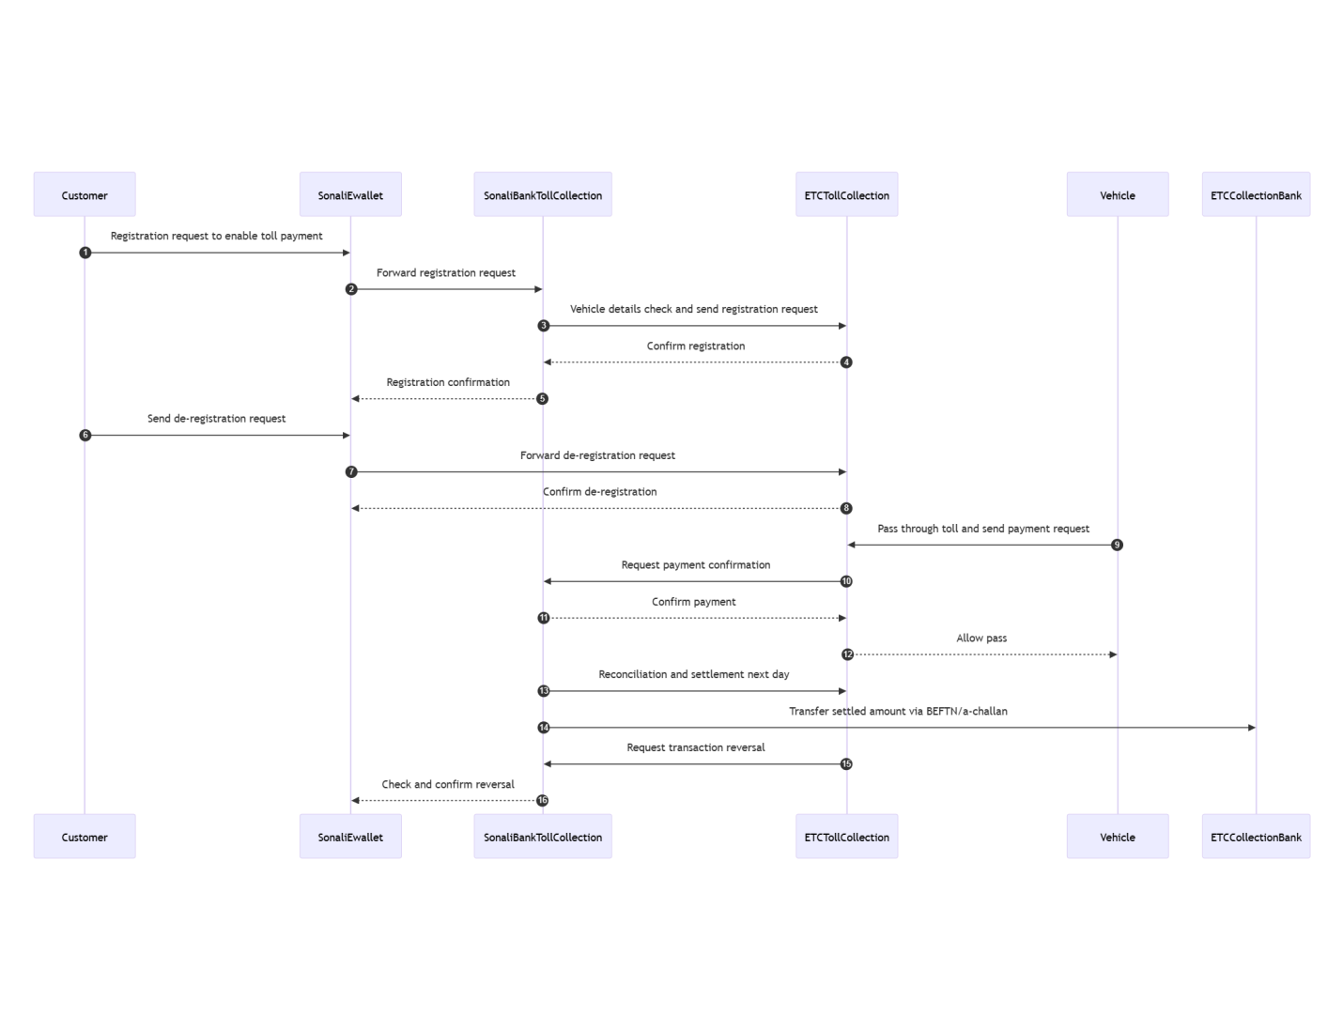
- Technical Strength of Sonali Bank PLC:
- High- Availability
- Load Balancers
- WAF
- REST API Integration
- Web based Applications
- Directly API based integrations

- Technology of Integration and Reconciliation with ETC system:

- Registration and payment transaction through REST API
- Network connectivity (VPN/ IP white list)
- Reconciliation- by shared csv file shared by sftp through VPN network , sonali bank will provide SFTP system.
- daily fund settlement completed t+1 through BEFTN

- API List:
- ETC API
  - Token API
  - Vehicle Checking API
  - Vehicle Registration API
  - Vehicle De-Registration API

- Sonali Bank API
  - Transaction API
  - Transaction Reverse API

- Stakeholder on This Project:
- ETC API system
- Sonali e-Wallet
- Sonali ETC Toll MW API

Conclusion
The integration of Sonali e-Wallet with the ETC Toll Collection System streamlines toll payments by enabling seamless, real-time transactions directly from customers’ Sonali Bank accounts. The process ensures secure registration, verification, toll payment, and settlement through a coordinated flow between the e-Wallet, Sonali Bank’s Toll Collection System, and the ETC platform. Additionally, provisions for de-registration and transaction reversal provide flexibility and reliability for users. This end-to-end digital solution enhances operational efficiency, ensures transparency in toll collection, and supports the broader goal of promoting cashless transportation infrastructure.

Thank’s

